Contents

Code repository 2

Environment setup 4

# Code repository

Instead of a single main branch, this workflow uses two branches to record the history of the project. The main branch stores the official release history, and the develop branch serves as an integration branch for features. It's also convenient to tag all commits in the main branch with a version number.

Create develop branch and push it to remote repo

*git branch develop*

*git push -u origin develop*

Create feature branch

*git checkout develop*

*git checkout -b feature_branch*

Add test file for feature branch, commit, push it and merge

*git checkout feature_branch*

*git add .*

*git commit -m “*[*Feature branch test*](https://github.com/anastaviki/ci-cd/commit/0d48fff08a402956b78e924a1a8602f0ad4dab24)*”*

*git push -u origin feature_branch*

*git checkout develop*

*git merge feature_branch*

*git push -u origin develop*

Feature branch can be deleted

*git push origin --delete feature_branch*



*git branch -d feature_branch*

Create release branch and push it

*git checkout develop*

*git checkout -b release/0.1.0*

*git push -u origin release/0.1.0*

Add some bug fixing in release branch commit changes and push to remote repo

*git add .*

*git commit -m “*[*Bug fix in release test*](https://github.com/anastaviki/ci-cd/commit/0d48fff08a402956b78e924a1a8602f0ad4dab24)*”*

*git push -u origin release/0.1.0*

Once the release is ready to ship, it will get merged it into main and develop, then the release branch will be deleted.

*git checkout main*

*git merge release/0.1.0*

*git push -u origin main*

*git checkout develop*

*git merge release/0.1.0*

*git push -u origin develop*

Create hot fix branch

*git checkout main*

*git checkout -b hotfix_branch*

Add changes, commit and push to remote repo

*git add .*

*git commit -m “*[*Hot fix test*](https://github.com/anastaviki/ci-cd/commit/0d48fff08a402956b78e924a1a8602f0ad4dab24)*”*

*git push -u origin hotfix_branch*

Similar to finishing a release branch, a hotfix branch gets merged into both main and develop.

*git checkout main*

*git merge hotfix_branch*

*git push -u origin main*

*git checkout develop*

*git merge hotfix_branch*

*git push -u origin develop*

Hot fix branch can be deleted

*git push origin --delete hotfix_branch*



*git branch -D hotfix_branch*

# Environment setup

Install Docker

Docker pull Jenkins/Jenkins

docker ps – show containers



Docker images – show images

docker run -p 8080:8080 --name=jenkins -d jenkins/Jenkins – run docker container



docker ps – show containers

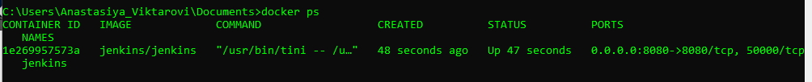

Check Jenkins

Find container ID

docker ps



Find admin password

docker exec -it 1e269957573a cat /var/jenkins_home/secrets/initialAdminPassword



And log it to jenkins

Install plugins for git

Create Admin user, as I already have git on my ps, use username from git



